Advanced String Making Tutorial
Complete with 3D diagrams for building a string jig.

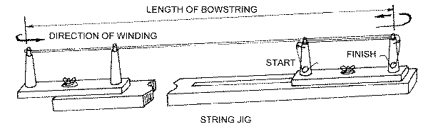
The length of the new string may be determined by placing the old string on the jig. Un-twist the old string before placing it on the jig, then adjust sliding arm until the string is held in tension.
(Note: old bowstrings, especially dacron, would have stretched over time, so the jig will have to be set slightly shorter to allow for stretch
ing of the new string.)
Start the thread by tying it to the bottom of the start post, then wind up the post to the top, then wind past the finish post and around t
he jig as shown above. Every complete turn makes two strands in the finished string e.g.. 8 turns makes 16 strand string. When the required number of strands are wound on, finish the thread by winding it around and down the finish post. This creates an overlap of the start and finish of the thread.
Adjust the sliding arm to place slightly more tension on the strands to even out the tension on all of the strands. All of the strands must
have an equal amount of tension on them before starting to serve.
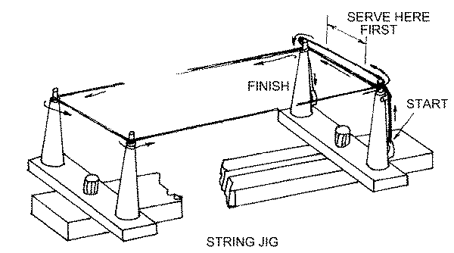
- Use the length of the served loop on the old string as a guide for the length of the new loop.
- Check the direction of twist in the strands and wind on the serving in the same direction.
- Make sure to adjust the tension on the serving jig so that the serving is wound on with even tension. Wind on enough serving to make the first loop, plus an overlap.
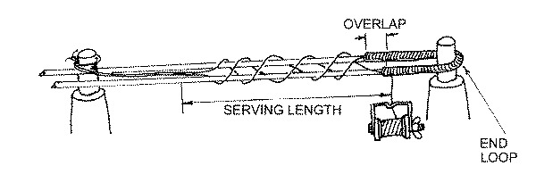
- Un-tie the start and finish ends of the thread and wrap around the string as shown above.
- Continue serving around the string until the the required length is achieved. The ends of the thread is now securely bound into the string and they can now be trimmed off.
- To tie off the serving, follow the steps shown below.
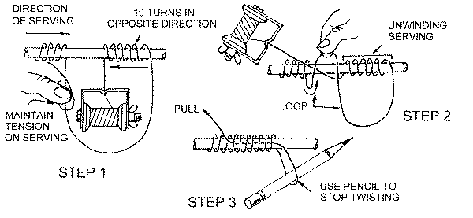
Make sure to wind the loop, as shown in step 2, over the end of the serving and with the same tension as the rest of the serving. Pull the loop under the serving to complete and trim off. A small dab of glue can be used to seal the end of the cut thread.
Now that the first loop serving is complete, adjust the serving jig arms to align with the string and maintain tension. Mark the string at the exact opposite end to the finish post.
This position will be the mid-point of the next loop serving. Mark off half the loop distance each side of this mark and start serving as for the first loop. When both loop servings are complete, remove the string from the serving jig and twist the string in the same direction as the twists in the strands. When the string has the same number of twists as the old string, then place the new string onto the bow.
This will help stretch the new bowstring. The bowstring should be waxed and rubbed to make the string round, ready for serving the 'centre serving'. Use the old string as a guide for the start and finish points of the centre serving. This serving must be wound on in the same direction as the twists in the string. To start the serving, lay a length of the serving (about 50mm) along the string and then wind on the serving over the top to bind the end in without using a knot. Continue winding on the serving maintaining an even tension. More tension is used for the centre serving to make sure that the threads do not slide up or down the string when in use.
- Remember that the nocking point locators are clamped over this serving, so it helps if the serving does not move.
- Finish off the serving as shown in the diagram above.
- It may take 50 to 100 shots for the bowstring to 'settle in', so take note of any changes in the brace height distance
- Set-up the nocking point locators in the correct location and you are ready to try out your new bowstring.
As a new bowstring will stretch, it can sometimes require that you make several bowstrings before getting just the right length to match the old set-up. Once you have it figured out, remember to note the length settings for the next bowstring.
There are many different thickness' of serving thread as well as different materials, such as monofilament and nylon. These materials are used for dacron strings
When making a 'Fastflite' bowstring, only use the 'Fastflite serving' material, especially for the centre serving, as the 'Fastflite' string material is very slippery.
Note: if you change your bowstring or type of serving material, it will effect the bow and arrow set-up, so you will have to re-tune the bow.

